CHAROTAR UNIVERSITY OF SCIENCE & TECHNOLOGY DEVANG PATEL INSTITUTE OF ADVANCE TECHNOLOGY & RESEARCH
Department of Information Technology

Subject Name: Data Engineering
Semester: 5th
Subject Code: ITUE301
Academic year: 2026-27 [ODD]
Practical File

PRACTICAL-1
Problem Definition:
Study, dissect, and map the complete end-to-end Data Engineering Lifecycle for an enterprise e-commerce platform. Students must trace data states across all five core lifecycle stages: Data Generation, Data Ingestion, Data Storage, Data Transformation, and Data Serving. The solution requires creating a detailed architectural data flow diagram along with a system manifesto documenting cross-cutting lifecycle undercurrents, including Security, Observability, and Data Privacy. The completed structure should be committed to a personal Git repository.
Key Questions:
● Que / Key Point 1: How do the technical demands of downstream serving layers directly influence ingestion and storage design decisions during the early generation
phases?
- Determine whether data should be ingested in real time (streaming) or in batches based on application requirements.
- Select an appropriate data format such as structured, semi-structured, or unstructured for efficient processing.
- Choose a suitable storage solution, including transactional databases, data lakes, or data warehouses.
- Apply data validation and quality checks during ingestion to ensure accurate downstream processing.
- Improve serving performance using indexing, partitioning, and optimized query strategies.
- Design the ingestion and storage layers to support scalability, reliability, and future business growth.
● Que / Key Point 2: Differentiate between the broader data lifecycle and the
technical data engineering lifecycle within an enterprise.
Data Lifecycle | Data Engineering Lifecycle
Covers the complete journey of data. | Focuses on technical processing of data.
Business-oriented. | Technology-oriented.
Includes creation, usage, archival, and deletion. | Includes ingestion, storage, transformation, and serving.
Involves business and compliance teams. | Involves data engineers and architects.

● Que / Key Point 3: Identify how the undercurrents of security and data
observability should be enforced at each lifecycle boundary.
1. Data Generation: Secure data collection using authenticated sources and monitor incoming data quality.
2. Data Ingestion: Encrypt data during transmission, validate incoming records, and monitor pipeline performance.
3. Data Storage: Protect stored data using encryption, role-based access control, backup policies, and continuous health monitoring.
4. Data Transformation: Ensure secure data processing, validate transformed data, and monitor processing accuracy.
5. Data Serving: Authenticate users, authorize data access, monitor query performance, and maintain audit logs for data access.

Supplementary Problems:
Map out the data engineering lifecycle for a smart city IoT
traffic sensor platform, emphasizing challenges related to continuous real-time streaming data generation.

1. Data Generation
- Traffic sensors continuously generate vehicle and road data.
- GPS, cameras, and IoT devices produce real-time streams.
- Challenge: High data volume and continuous data generation.

2. Data Ingestion
- Streaming platforms collect sensor data in real time.
- Handle thousands of events per second.
- Challenge: Low latency and reliable data transmission.

3. Data Storage
- Store raw data in a data lake and processed data in databases.
- Partition data based on location and time.
- Challenge: Scalable storage for massive datasets.

4. Data Processing / Transformation
- Clean, validate, and aggregate sensor data.
- Remove duplicate or missing records.
- Challenge: Real-time processing with minimal delay.

5. Data Serving
- Deliver live traffic updates to dashboards and navigation apps.
- Provide APIs for traffic management systems.
- Challenge: Fast query response and high availability.

6. Data Consumption
- Used by traffic authorities, commuters, and emergency services.
- Supports congestion analysis and route optimization.
- Challenge: Accurate and up-to-date information.

7. Monitoring & Maintenance
- Monitor sensor health and pipeline performance.
- Detect failures and data anomalies.
- Challenge: Ensuring continuous operation and data quality.

Major Challenges of Continuous Real-Time Streaming
• Managing high-speed continuous data generation.
• Ensuring low-latency data ingestion and processing.
• Handling network failures and preventing data loss.
• Providing scalable storage and processing infrastructure.
• Maintaining data security, privacy, and regulatory compliance.
• Continuously monitoring system health and data quality.

OUTPUT:
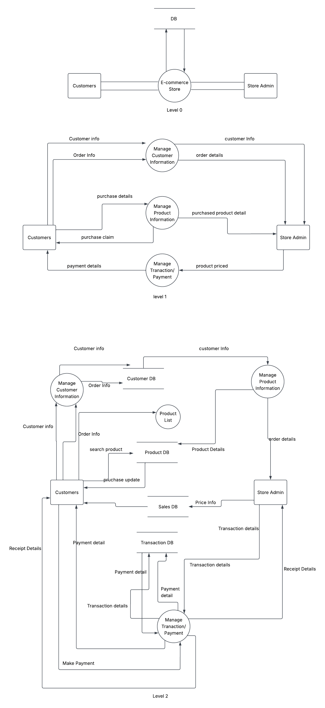
Figure 1: Enterprise E-Commerce Data Flow Diagram (Level 0, Level 1, and Level 2)

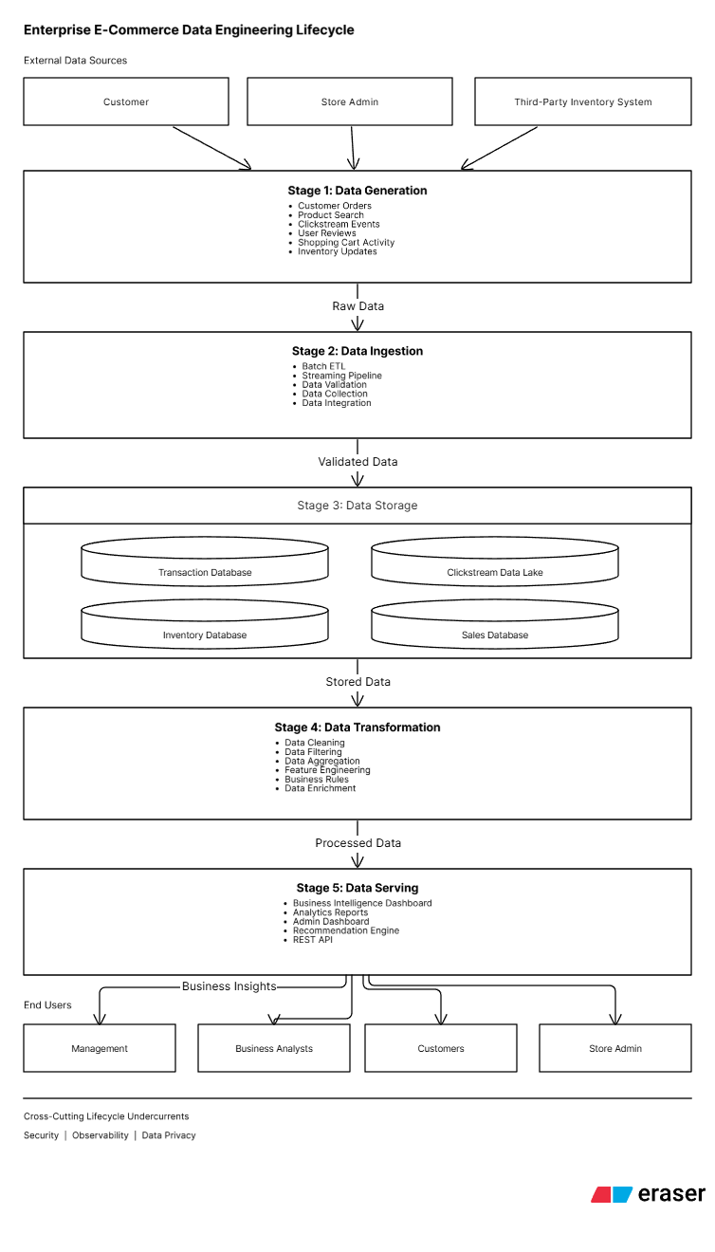
Figure 2: Enterprise E-Commerce Data Engineering Lifecycle Diagram

